Data Operations - Filtering

Definition
# Source: AI Source: Provided by: [Data Path: Persons Table -> ID Column: 1, Name_En Column: Motasem Essam] -> From: [Chatgpt (GPT‑5 Mini)] on [12/10/2025]
Filtering is the process of selecting only the data that meets specific criteria while ignoring the rest.
- It allows users to focus on relevant records for analysis or reporting.
Key idea:
It’s like using a strainer to separate what you need from what you don’t.

Characteristics of Filtering
# Source: AI Source: Provided by: [Data Path: Persons Table -> ID Column: 1, Name_En Column: Motasem Essam] -> From: [Chatgpt (GPT‑5 Mini)] on [12/10/2025]
- Works on one or multiple conditions (e.g., Score > 80 AND Class = ‘10A’)
- Can be applied to databases, spreadsheets, or datasets
- Reduces data clutter by showing only relevant rows
- Often combined with sorting or queries for more precise results
- Essential for analysis, reporting, and decision-making

Example
# Source: AI Source: Provided by: [Data Path: Persons Table -> ID Column: 1, Name_En Column: Motasem Essam] -> From: [Chatgpt (GPT‑5 Mini)] on [12/10/2025]
A student database:
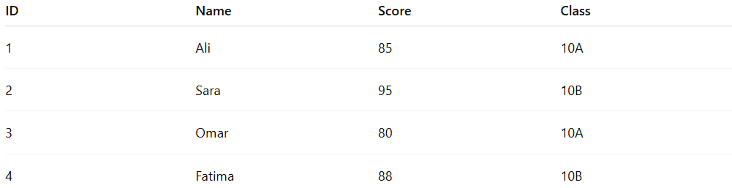
ID | Name | Score | Class
1 | Ali | 85 | 10A
2 | Sara | 95 | 10B
3 | Omar | 80 | 10A
4 | Fatima | 88 | 10B
- Filter students with Score > 85:
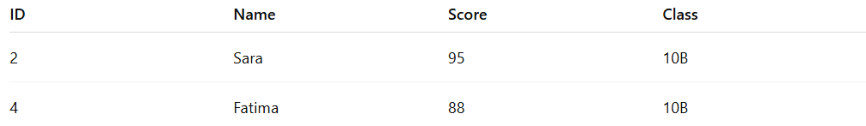
ID | Name | Score | Class
2 | Sara | 95 | 10B
4 | Fatima | 88 | 10B

Example Section
# Source: AI Source: Provided by: [Data Path: Persons Table -> ID Column: 1, Name_En Column: Motasem Essam] -> From: [Chatgpt (GPT‑5 Mini)] on [12/10/2025]
A teacher wants to see only students who scored more than 85:
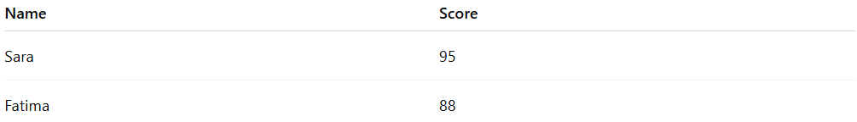
Name | Score
Sara | 95
Fatima | 88
- Filtering allows the teacher to focus only on top-performing students without viewing all records.
- This is filter-based retrieval, making large datasets easier to analyze.

Advantages
# Source: AI Source: Provided by: [Data Path: Persons Table -> ID Column: 1, Name_En Column: Motasem Essam] -> From: [Chatgpt (GPT‑5 Mini)] on [12/10/2025]
- Shows only relevant data for analysis
- Reduces time and effort when working with large datasets
- Can be combined with sorting, queries, or indexing
- Improves clarity and decision-making

Disadvantages
# Source: AI Source: Provided by: [Data Path: Persons Table -> ID Column: 1, Name_En Column: Motasem Essam] -> From: [Chatgpt (GPT‑5 Mini)] on [12/10/2025]
- Important data may be accidentally excluded if filter conditions are too strict
- Over-filtering can hide trends or patterns in the full dataset
- Requires careful definition of filter criteria to avoid mistakes
- May require extra processing power for large datasets or complex conditions

